Computer Language Coding Concepts

Remove in a Diagram
The concept of Remove is explained in the article Remove. The current article demonstrates its expression in a diagram.

The system member Remove is part of the system interface of a related list item and is displayed in a diagram as follows:

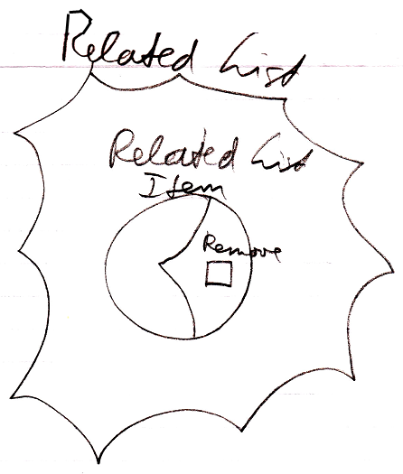

See also: System Objects, Remove

Author & Copyright: Jan-Joost van Zon Date: July 18, 2008 – July 18, 2008 Location: Oosterhout, The Netherlands Status: Finished

